Generative Multi-Adversarial Networks
Introduction
In recent years, generative models have significantly advanced the field of artificial intelligence, enabling machines to synthesize high-quality and realistic data. Among these, Generative Adversarial Networks (GANs) have emerged as a powerful tool for applications such as natural image generation, medical image synthesis, and even creative tasks like artwork generation. However, despite their potential, GANs often suffer from issues such as mode collapse, unstable training, and slow convergence. These problems are especially detrimental in domains requiring high sample diversity and fidelity such as autonomous driving, where synthetic yet realistic road scenarios can enhance safety validation and training efficiency.
A growing body of literature has explored strategies to stabilize GAN training. Approaches such as MAD-GAN [1], MGGAN [2], and MMGAN [3] introduce architectural changes or loss function modifications to encourage mode diversity or capture multi-modal data distributions. Yet, many of these solutions either require extensive architectural tuning, external feature extractors, or significant deviations from the original GAN framework. This not only complicates training but also limits the generalizability of the solutions across different datasets and tasks.
Our project introduces GMAN (Generative Multi-Adversarial Network), a framework that aims to enhance the stability and diversity of image generation while preserving the original GAN objective function. Instead of altering the loss formulation, we propose using multiple discriminators, each configured with different dropout rates and internal structures to provide diverse feedback to a single generator. This ensemble of discriminators allows for a more comprehensive evaluation of generated samples, encouraging the generator to explore various aspects of the data distribution.
The core contributions of our project are as follows:
- Implementation of a novel GAN architecture with up to four discriminators, investigating how varying dropout rates and filtering strategies affect training dynamics.
- Evaluation of the model’s performance in terms of generation quality, mode diversity, and convergence speed using standard natural image datasets.
- Validation of generalizability by keeping the original GAN loss function, demonstrating that our enhancements improve training stability across tasks without additional objective modifications.

Related Work
This paper​ [1]​ introduces MAD-GAN (Multi-Agent Diverse Generative Adversarial Network), an approach to address mode collapse in GANs. MAD-GAN uses multiple generators and a single discriminator. The discriminator's objective is extended to not only distinguish real from fake samples, but also identify which generator produced a given fake sample. This method forces generators to specialize in different high-probability modes of the data distribution, resulting in diverse sample generation. The key difference between this paper and our work lies in their approach to mitigating mode collapse in GANs. MAD-GAN tackles this by introducing multiple generators and modifying the discriminator to identify the generator of a given fake sample. Our work, GMAN, uses a single generator but incorporates multiple discriminators. This allows GMAN to reliably train using the original, unmodified GAN minimax objective, unlike MAD-GAN which requires adjustments to the objective function.
The next significant contribution to our work comes from Yu et al. In their work​ [2]​, they propose Multi-Granularity Generative Adversarial Network (MGGAN), that is a GAN architecture designed for wafer map defect recognition (WMDR). MGGAN incorporates three sub-networks: a pre-trained ResNet101 as an Auxiliary Feature Extractor (AFE) to provide multi-granularity features guiding the generator; a generator (G) that reconstructs wafer maps using both random noise and AFE features; and a lightweight discriminator (D) using group convolutions and depth wise separable convolutions to classify image source and defect type. The generator's objective function includes a feature matching term to minimize the difference between real and generated features, enhancing adversarial training stability. The core difference between MGGAN and our work is the application of both GANS. Our work, GMAN, focuses on improving the general training stability and convergence speed of GANs by using multiple discriminators and aggregating their feedback. The multiple discriminators act as an ensemble, providing more robust and less variable feedback to the single generator. However, the MGGAN, is specifically designed for the task of wafer map defect recognition, which uses a pre-trained network to provide auxiliary information to guide the generation of specific types of images to address dataset-specific issues.
Pandeva et al​ [3]​ proposes MMGAN (Multi-Modal Generative Adversarial Network), a novel GAN architecture designed to model multi-modal data distributions. Standard GANs struggle with multi-modal data, often suffering from unstable training and mode dropping (failure to capture all data modes). MMGAN addresses this by explicitly modeling the latent space as a Gaussian Mixture Model (GMM), where each Gaussian component corresponds to a distinct data mode or cluster. A key component of MMGAN is an encoder network that predicts the cluster assignment for each data point. The training process involves creating pairings of real and fake data points from the same cluster, feeding these pairings to the discriminator, and training the encoder to correctly classify the clusters of the generated data. Our work uses multiple discriminators for better training, while MMGAN uses a GMM latent space and an encoder to model multi-modal data.
Current Work
Generative Adversarial Networks (GANs) typically use a single discriminator to evaluate generated data, but this approach can lead to challenges such as mode collapse, slow convergence, and unstable training. Training GANs often requires modifying the objective function, adding complexity to the process.
To Do: We aim to implement and evaluate a multi-discriminator GAN, where multiple discriminators each with different dropout rates and internal functions assess different aspects of the generated images.
Assumptions: The problem is framed as a supervised learning task, where labeled training data is used to guide the generator. Each discriminator contributes uniquely to evaluating image quality, and the fundamental GAN objective function remains unchanged. In this paper ​[4]​, we build upon generative multi-adversarial networks (GANs) but explore a novel approach: instead of using just 1, 2, or 5 discriminators, we employ 1, 2, 3, and 4 discriminators with varying dropout rates and convolutional layers. Our goal is to evaluate the system's performance in generating natural images, measuring generation time, and assessing mode collapse.
Our framework consists of two key components:
- A generator, which produces images resembling a natural distribution.
- A discriminator, which learns the dataset's distribution and determines whether an image is real or synthetic.
Both networks optimize using binary cross-entropy loss (formula), allowing the generator to improve iteratively by learning from the discriminator’s feedback.
Experimental Evaluation
Research Questions
Our study investigates the impact of using multiple discriminators within the traditional GAN framework, focusing on the following key research questions:
- Q1: Does the use of multiple discriminators improve the stability and convergence of GAN training compared to a single discriminator setup?
- Q2: Does the proposed multi-discriminator GAN (GMAN) lead to improvements in generative diversity and sample quality?
- Q3: Can the proposed architecture generalize across different image datasets without requiring changes to the original GAN loss formulation?
Experimental Setup
To evaluate the GMAN framework, we designed experiments across multiple configurations with varying numbers of discriminators (1, 2, 3, and 4). Each discriminator is configured with different dropout rates and filtering mechanisms to diversify the feedback received by the generator.
- Datasets: We used three natural image datasets, namely MNIST, CelebA and CIFAR-10 to test generalizability and visual diversity. Each dataset was split 80/20 into training and test sets.
- Runs and Averaging: Each experiment was run five times, and the results reported are averaged across runs to ensure statistical robustness.
- Environment: Experiments were conducted on a machine with the following configuration:
  - 3 ‘Microsoft 11’ computers, GPU enabled, 64 GB RAM, Python 3.10, PyTorch 2.1
- GAN Training Details:
  - Generator and discriminator use Adam optimizer (learning rate = 0.002)
  - Latent dimension = 100
  - Binary cross-entropy loss was used, with no changes to the standard GAN objective
  - Batch size = 32, number of epochs = 10
Baselines Considered
We compared our approach against the following baseline models:
- Vanilla GAN: A standard GAN architecture with one generator and one discriminator.
- MAD-GAN [1]: A multi-generator, single-discriminator model designed to reduce mode collapse.
- MGGAN [2]: Uses an auxiliary feature extractor for more robust generation, especially on structured data.
- MMGAN [3]: Models multi-modal latent distributions using Gaussian Mixture Models.
While MAD-GAN and MMGAN introduce significant architectural changes, our method retains the core GAN loss function, enabling a direct comparison in terms of stability and performance under minimal modifications.
Performance Metric Reported
In our system, we chose 2 performance metrics.
Convergence Speed: Tracked via discriminator and generator loss over time.
The results for each dataset are presented below: Representing CelebA, CIFAR, MNIST respectively
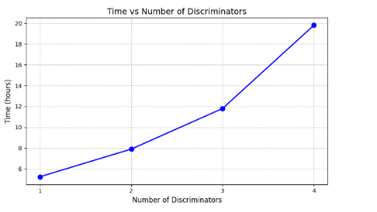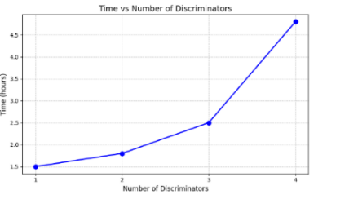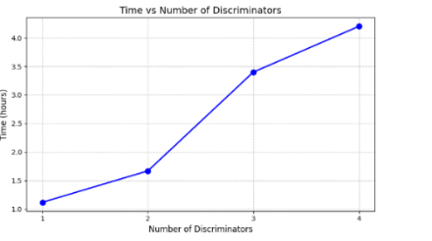
Training Instability: Measures how well the generators and discriminators did relative to each other.
The results for each dataset are presented here:
MNIST:
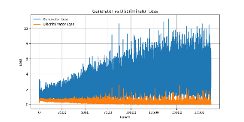 | 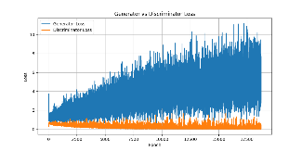 | 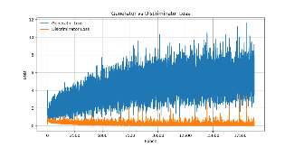 | 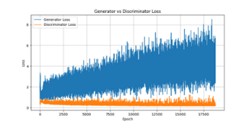

CIFAR:
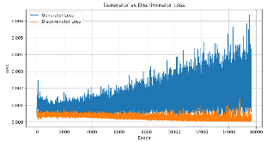 | 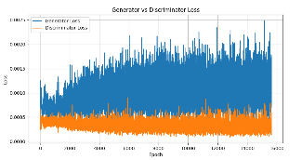 | 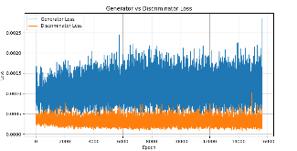 | 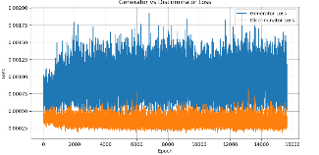

CELEB:
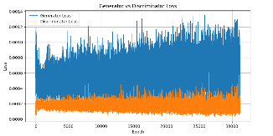 | 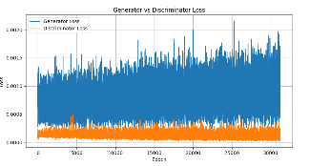 | 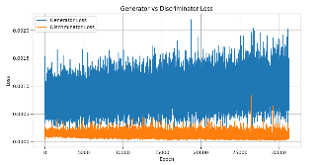 | 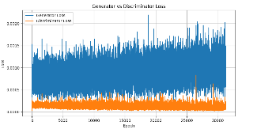

Results
These are the results of running our various models on the datasets:
- MNIST
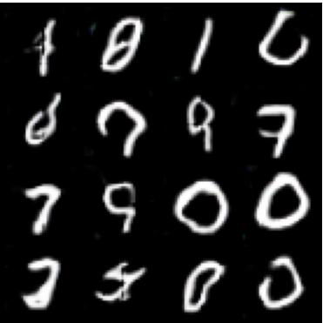 | 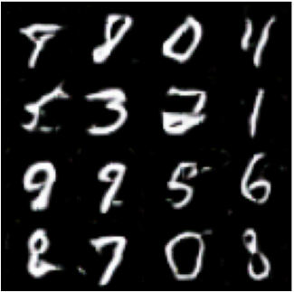 | 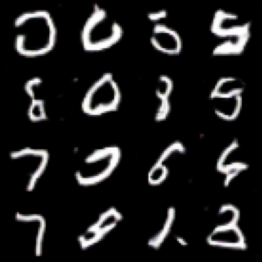 | 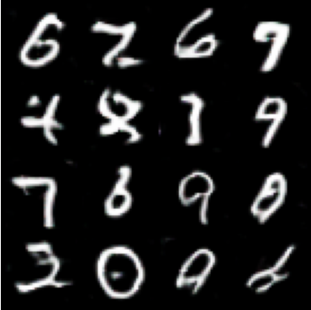

- CELEB
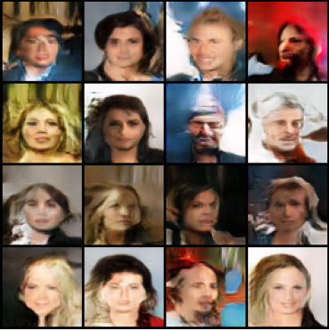 | 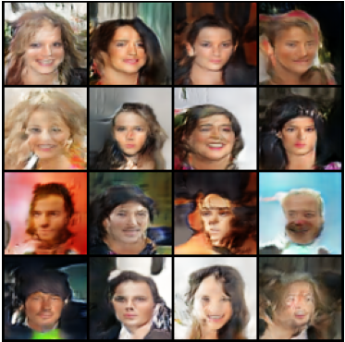 | 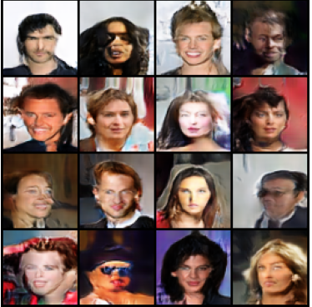 | 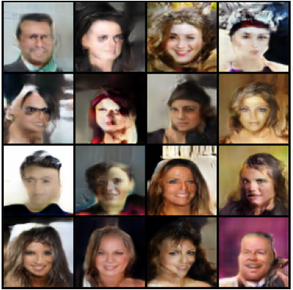

- CIFAR
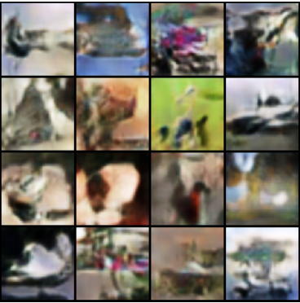 | 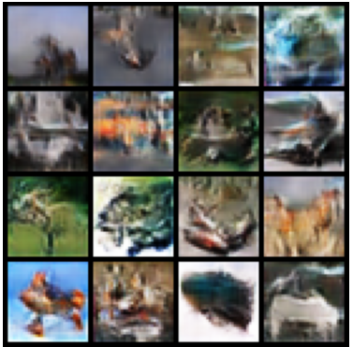 | 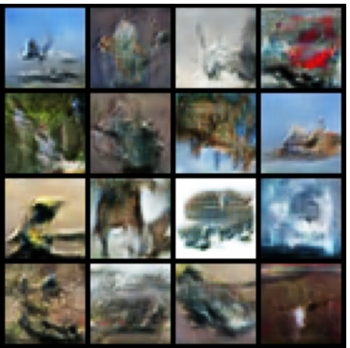 | 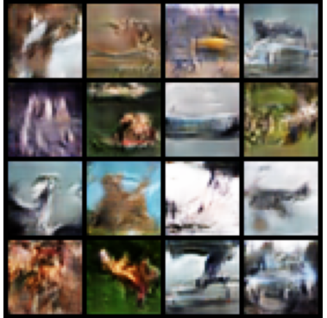
In the images above, the discriminators go from 1 to 4 as the images go from left to right. The general trend is that as the images go from left to right, they generally improve in the data distribution.
Discussion to research questions
Q1. The results confirm that adding multiple discriminators improves training stability and convergence speed. The variance across runs was lower in GMAN setups, and training required fewer epochs to reach optimal performance.
Q2. GMAN configurations outperformed Vanilla GAN, indicating higher generative quality and diversity. This improvement highlights GMAN’s strength in handling more complex data distributions.
Q3. The consistent improvement across all three datasets, without modifying the objective loss function, supports the claim of generalizability
Contributions
Chineme Uba: Responsible for experimental setup and results. Also responsible for validating the model and ensuring code is error free. Assisted in final project report write up.
Michael Acquah: Responsible for training the model and collecting experimental data. Assisted in final project report write up.
References
​​[1] A. Ghosh, V. Kulharia, V. Namboodiri, P. H. S. Torr, and P. K. Dokania, “Multi-Agent Diverse Generative Adversarial Networks.”
​[2] J. Yu and J. Liu, “Multiple Granularities Generative Adversarial Network for Recognition of Wafer Map Defects,” IEEE Trans Industr Inform, vol. 18, no. 3, pp. 1674–1683, Mar. 2022, doi: 10.1109/TII.2021.3092372.
​[3] T. Pandeva and M. Schubert, “MMGAN: Generative Adversarial Networks for Multi-Modal Distributions,” Nov. 2019, [Online]. Available: http://arxiv.org/abs/1911.06663
​[4] I. Durugkar, I. Gemp, and S. Mahadevan, “Generative Multi-Adversarial Networks,” Nov. 2016, [Online]. Available: http://arxiv.org/abs/1611.01673

